Revision History
Date | Version | Description | Author
21/11/2018 | 1.0 | Added component diagram for section 2. Added class diagrams for component 1,2 and 3 | Ataberk Ozek
21/11/2018 | 1.1 | Added component interfaces for all components | Alp Demirezen
22/11/2018 | 1.2 | Added activity diagrams for all components | Alp Demirezen

TABLE OF CONTENTS
Revision History 1
1 Introduction 3
1.1 References 3
1.1.1 Project References 3
2 Software Architecture overview 3
3 Software design description 3
3.1 Component 1 3
3.1.1 Component interfaces 3
3.1.2 Component design description 4
3.1.3 Workflows and algorithms 4
3.1.4 Software requirements mapping 4
3.2 Component 2 4
3.2.1 Component interfaces 4
3.2.2 Component design description 5
3.2.3 Workflows and algorithms 5
3.2.4 Software requirements mapping 5
3.3 Component 3 5
3.3.1 Component interfaces 5
3.3.2 Component design description 6
3.3.3 Workflows and algorithms 6
3.3.4 Software requirements mapping 6
4 COTS Identification 6

Introduction

This document describes the design of the REP software system.

References

Project References

# | Document Identifier | Document Title
[SRS] | REP-SRS-1 | REP Software Requirements Specifications

Software Architecture overview

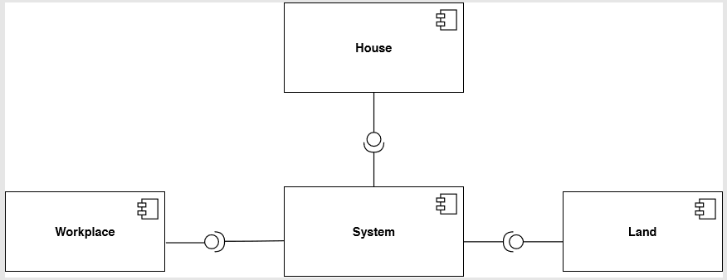

Software design description
Describe each top level package/component of your software in the following subsections. The number of sub-sections (3.1, 3.2, … etc.) depends on the number of packages/components in your architecture diagram.

Component 1

Component interfaces
House will be an interface which will have “For sale” as an input of Boolean. House will be an interface which will have “For sale” as an input of Boolean.

Component design description

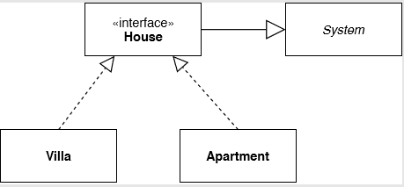

Workflows and algorithms

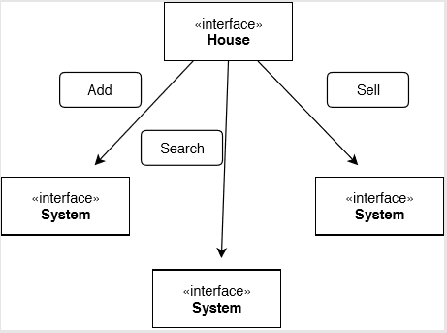

Software requirements mapping
List the SRS requirements handled by this component

Component 2
Repeat the pattern for each component.

Component interfaces
Workplace will be an interface which will have “For sale” as an input of Boolean. House will be an interface which will have “For sale” as an input of Boolean.

Component design description

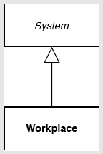

Workflows and algorithms

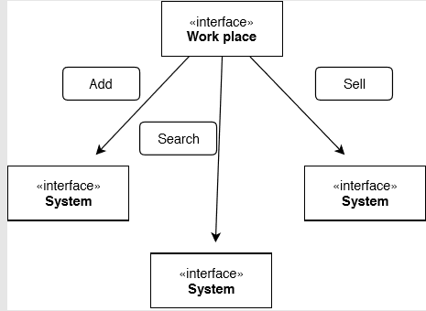

Software requirements mapping
List the SRS requirements handled by this component

Component 3
Repeat the pattern for each component.

Component interfaces
Land will be an interface which will have “For sale” as an input of Boolean. House will be an interface which will have “For sale” as an input of Boolean.

Component design description

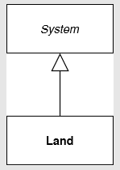

Workflows and algorithms

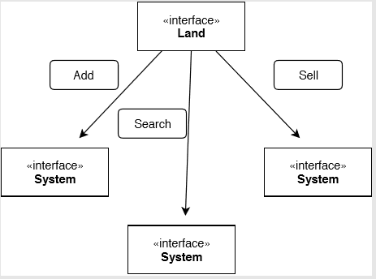

Software requirements mapping
List the SRS requirements handled by this component

COTS Identification
List external software components/libraries that your system relies on, if there are any.
Example:
COTS (commercial of the shelf) libraries used in XXX are the following:
- foo.jar, version id, download URL, License type,
- bar.jar, version id, download URL, License type,

